

COMPARATIVE ANALYSIS OF KUBERNETES SCHEDULERS FOR BIG DATA

By,
Kavya V
2021WA86612
Dissertation Work carried out at
Wipro Technologies, Bangalore

BIRLA INSTITUTE OF TECHNOLOGY AND SCIENCE
Pilani (Rajasthan) India

November - 2025

Abstract

The rapid growth of big data applications has driven the adoption of distributed computing frameworks like Apache Spark, which are increasingly deployed on container orchestration platforms such as Kubernetes. While Kubernetes excels at managing containerized environments, its default scheduler is primarily designed for long-running services and fails to meet the specific requirements of batch-processing workloads. These workloads demand “gang scheduling”, where all tasks must start simultaneously and consequently suffer from resource deadlocks and inefficiencies under the default scheduler.

This dissertation presents an empirical performance analysis comparing the default Kubernetes scheduler with the specialized, batch-aware Volcano scheduler. Using a multi-node Kubernetes cluster and standardized Apache Spark benchmarks, this study systematically collected and analysed key performance indicators.

The results are definitive: the default scheduler is fundamentally unsuitable for parallel batch workloads, leading to job failures due to resource deadlocks. In stark contrast, Volcano's "all-or-nothing" gang scheduling mechanism solves this problem, achieving a 100% job success rate. The data further reveals that Volcano is dramatically more efficient. On successful runs, Volcano completed jobs in ~2.5 minutes (2 min 29 sec), while the default scheduler took over 9.5 minutes (9 min 33 sec). This is underpinned by a ~100x higher scheduler throughput (~0.98 pods/s for Volcano vs. ~0.01 pods/s for the default) and lower p99 scheduling latency (112 ms vs. 158.4 ms). This superior performance comes at a negligible cost, with Volcano's application-aware logic requiring only a minor increase in CPU (~0.02 cores) and memory (~4 MiB). This research concludes that adopting a specialized, batch-aware scheduler is not merely an optimization but a foundational requirement for any reliable and performant big data platform on Kubernetes.

Table of Contents
Abstract 5
1. Introduction 7
1.1 Background
1.2 System Architecture
2. Background 9
2.1 Existing System (and its Limitations)
2.2 Proposed System
3. Literature Review 11
3.6 Analysis and Comparison with Published Literature
4. Methodology 15
5. Requirements 17
6. Design Specifications 18
6.1 Context Diagram
6.2 Default scheduler workflow
6.3 Scheduling process diagram for default scheduler
6.4 Volcano Scheduler workflow
7. Results and Analysis 20
7.1 Experimental Results
8. Conclusion and Future Work 22
9. List of References 24

List of Figures
Fig 6.1: Context diagram
Fig 6.2: Default scheduler workflow
Fig 6.3: Scheduling process diagram for default scheduler
Fig 6.4: Volcano Scheduler workflow

List of Tables
Tab 7.1: Experimental Results
Tab 3.6: Analysis and Comparison with Published Literature

1. Introduction

1.1 Background
In the contemporary technological landscape, the ability to process and analyse vast quantities of data has become a critical driver of innovation and competitive advantage across industries. Big data workloads, which involve processing datasets at a scale that exceeds the capabilities of traditional database systems, require distributed computing frameworks. Apache Spark has emerged as a leading engine for large-scale data processing due to its in-memory computation capabilities, which offer significant speed advantages over earlier frameworks like Hadoop MapReduce.

Concurrently, the paradigm for deploying and managing applications has shifted towards containerization and microservices architectures. Kubernetes, an open-source container orchestration platform, has become the de facto industry standard for automating the deployment, scaling, and management of containerized applications. Its resilience, portability, and extensive ecosystem have driven its adoption for a wide range of applications, including stateful services, web applications, and, increasingly, data processing pipelines.

However, running big data workloads on Kubernetes introduces a significant challenge at the resource management and scheduling layer. The default Kubernetes scheduler is a generalist, designed to place individual containers (pods) onto cluster nodes based on resource availability and predefined constraints. While effective for stateless, long-running services, it lacks the context-awareness required for complex batch jobs.

A typical Spark application, for instance, consists of a driver pod and multiple executor pods that must run concurrently to make progress. The default scheduler's pod-at-a-time scheduling approach can lead to a critical issue known as resource deadlock: the driver may be scheduled, but if insufficient resources are available for the executors, the job will idle indefinitely, wasting valuable cluster resources.

This limitation has spurred the development of specialized schedulers designed explicitly for batch, big data, and high-performance computing (HPC) workloads. Schedulers like Volcano and Apache YuniKorn introduce critical concepts such as gang scheduling, hierarchical queuing, and advanced fairness algorithms. Gang scheduling ensures that a job only starts when all its required components can be placed simultaneously, thereby preventing deadlocks. This dissertation aims to rigorously evaluate and quantify the performance benefits of using such a specialized scheduler in place of the default Kubernetes scheduler for running Apache Spark workloads.

1.2 System Architecture
The experimental environment for this comparative analysis is architected to be a realistic, scalable, and observable representation of a modern data processing platform. The architecture is composed of several key layers.

- Infrastructure Layer: A multi-node Kubernetes cluster serves as the foundation. This layer consists of the physical or virtual machines, networking, and storage resources that form the cluster. The setup is designed to be agnostic of the underlying provider, focusing on a standardized compute environment.

- Orchestration Layer: Kubernetes is the core of this layer. At the center there is Kubernetes Control Plane, which manages the state of the cluster. The key component under investigation is the Scheduler. The architecture is designed to allow for the scheduler component to be swapped, first using the default kube-scheduler for baseline measurements, and subsequently using the Volcano scheduler for comparative tests.

- Application Workload Layer: Apache Spark applications constitute the workload. The Spark Operator for Kubernetes is deployed for the submission and management of Spark jobs. This operator translates high-level SparkApplication custom resource definitions into the underlying Kubernetes resources (e.g., driver and executor pods).

- Monitoring and Observability Layer: A comprehensive monitoring stack is essential for collecting the quantitative data required for analysis. This layer is built using industry-standard open-source monitoring solution:

  - Prometheus: A time-series database used to scrape and store metrics from all components of the cluster, including node resource usage, pod statuses, and scheduler performance.

  - Grafana: A visualization tool used to create dashboards for real-time monitoring and to query Prometheus for the data needed for the final analysis. This layered architecture ensures that experiments are repeatable, and the results are grounded in precise, verifiable metrics.

2. Background

2.1 Existing System
The existing or baseline system for running big data workloads on Kubernetes relies on the default kube-scheduler. It operates on a simple yet effective two-phase process for each pod it needs to schedule:

- Filtering (Predicates): The scheduler identifies a set of feasible nodes where the pod could be placed. This is a process of elimination based on hard constraints. For example, it filters out nodes that do not have sufficient CPU or memory, nodes that have taints the pod cannot tolerate, or nodes that do not match the pod's node affinity rules.

- Scoring (Priorities): From the list of feasible nodes, the scheduler ranks each one to find the best fit. The scoring is based on a set of priority functions, such as preferring nodes with the least requested resources (to spread the load) or nodes that already have the container image cached (to speed up startup). The node with the highest total score is selected.

Limitations of the Existing System:

- Lack of Gang Scheduling: This is the system's most significant flaw for batch processing. The scheduler is "job-unaware" and evaluates pods individually. It can successfully schedule a Spark driver pod, but if the cluster lacks the cumulative resources for all required executor pods, those executors will remain in a 'Pending' state. This creates a resource deadlock: the driver pod consumes resources while sitting idle, waiting for executors that can never be scheduled, ultimately causing the entire job to fail and wasting cluster resources.

- Job-Unaware Resource Management: The scheduler's fairness logic is pod-level, not job-level. In a multi-tenant environment, a single user submitting a large job (a "pod flood") can easily consume all available resources and starve other, smaller jobs.

- Inefficient Preemption: While Kubernetes supports preemption, its logic is not optimized for batch jobs. It might evict a single low-priority pod to make room for one high-priority pod. However, it doesn't understand that preempting a single running executor from a high-priority Spark job could render that entire job useless, making the preemption counter-productive.

2.2 Proposed System
The proposed system augments the standard Kubernetes architecture with a specialized, pluggable scheduler designed for big data. For this study, Volcano is selected as the alternative scheduler. It integrates seamlessly with Kubernetes but replaces the core scheduling logic with one that is batch-aware.

- Key Features and Improvements:

  - Gang Scheduling: Volcano introduces the "all-or-nothing" principle of gang scheduling through its PodGroup custom resource. It will not schedule any part of a job until the minimum required resources for the entire job are available and can be allocated simultaneously. This completely eliminates the resource deadlock problem inherent in the existing system.

  - Advanced Queue Management: Volcano implements a concept of queues. Jobs can be submitted to different queues, each with its own resource quotas, priorities, and scheduling policies. This enables robust multi-tenancy and ensures that different users or departments receive their fair share of cluster resources.

  - Job-based Scheduling Logic: Unlike the pod-centric default scheduler, Volcano's decisions are job-aware. It considers job priority, queue status, and fairness policies when deciding which job to schedule next, leading to higher overall cluster throughput.

  - Enhanced Preemption: Volcano's preemption logic is more intelligent for batch workloads. It can preempt entire low-priority jobs to make room for high-priority ones, which is a more effective strategy than the pod-level preemption of the default scheduler.

By implementing this system, we hypothesize a significant improvement in job success rates, a reduction in average job completion time, and more efficient and equitable cluster utilization.

3. Literature Review
The convergence of large-scale data processing frameworks and container orchestration platforms represents a pivotal transformation in modern computing infrastructure. This section reviews existing academic and industry research relevant to big data scheduling, the limitations of Kubernetes’ default scheduler, and the emergence of specialized, batch-aware schedulers such as Volcano. The literature traces this evolution from traditional schedulers like YARN and Mesos to the new generation of Kubernetes-native scheduling systems designed for high-performance, parallel workloads.

3.1 From Traditional Schedulers to Kubernetes

Historically, large-scale data analytics frameworks such as Apache Hadoop and Apache Spark depended on dedicated cluster resource managers like Yet Another Resource Negotiator (YARN) and Apache Mesos. As highlighted by Wang et al. (2018), YARN was specifically engineered for the Hadoop ecosystem, offering robust yet tightly coupled scheduling for MapReduce and Spark jobs. While effective in homogeneous environments, these systems often led to operational silos, where separate clusters were maintained for analytics and for microservices workloads.

The growing demand for unified infrastructure gave rise to the use of Kubernetes as a common orchestration platform. Nanda (2021) and CERN (2018) emphasized that Kubernetes provides a standardized, container-based ecosystem offering resource sharing, scalability, and portability. This shift enabled organizations to deploy both stateless applications and stateful data-processing jobs on a single platform. However, it also introduced a new set of challenges in the domain of resource scheduling and job coordination.

3.2 Limitations of the Default Kubernetes Scheduler

The default Kubernetes scheduler (kube-scheduler) is fundamentally designed for long-running, stateless services rather than data-intensive batch workloads. Studies by Senjab et al. (2023) and Rejiba et al. (2022) describe it as a single-pod, application-unaware scheduler that makes decisions independently for each pod without understanding interdependencies within distributed jobs. For frameworks like Spark, which rely on concurrent driver and executor pods, this limitation often leads to resource deadlocks—a state in which a Spark driver is scheduled but executor pods remain pending indefinitely due to insufficient resources.

Experimental research (e.g., Jeon et al., 2019; Chen et al., 2020) confirmed this behavior, showing that Spark jobs frequently fail or hang under the default scheduler. Comparative analyses such as “A Performance Study of Spark on Kubernetes” (IEEE, 2022) demonstrated inconsistent job success rates and degraded throughput due to Kubernetes’ inability to co-schedule related pods. In summary, while the default scheduler is effective for microservices, it performs poorly for batch-oriented, parallel applications.

3.3 Emergence of Specialized Batch-Aware Schedulers

In response to these limitations, the cloud-native community introduced specialized schedulers built specifically for batch and high-performance workloads. The CNCF Batch Working Group and projects like Volcano, Apache YuniKorn, and Kueue emerged as solutions to bridge the gap between Kubernetes and traditional HPC schedulers. Among these, Volcano (CNCF, 2019) gained prominence as a Kubernetes-native batch scheduler with advanced features such as Gang Scheduling, Job Queuing, and Fairness Policies.
According to Lövenvald (2021) and Volcano’s official documentation (Volcano.sh, 2025), Gang Scheduling implements an “all-or-nothing” policy: a job’s pods are only scheduled when all required resources for the entire group (driver and executors) are available simultaneously. This eliminates the resource deadlocks observed with the default scheduler. Moreover, Huawei (2024) reported that Volcano can handle up to 1000 pod scheduling operations per second, making it significantly more efficient for high-volume environments. Industry case studies (Altoros, 2022) also documented Volcano’s use in production clusters managing over 300,000 pods per day, validating its scalability and reliability.

3.4 Comparative Studies and Observations

Several research works have compared the performance of specialized schedulers to Kubernetes’ default mechanism. Kubeflow (2025) and CNCF (2022) studies indicate that Volcano improves Spark job performance by more than 30% due to its batch-aware logic. Wan (2021) emphasized that Volcano’s queue-based resource sharing leads to higher job throughput and better fairness in multi-tenant environments. Likewise, Li et al. (2022) analysed scheduling strategies for academic computing labs and confirmed that job-aware schedulers enhance overall cluster efficiency and minimize job starvation.

The findings across literature consistently validate that application-aware scheduling particularly gang scheduling plays a crucial role in maintaining high job success rates, predictable execution times, and efficient resource utilization for parallel big data workloads on Kubernetes.

3.5 Advancements and Future Research Directions

Recent research extends beyond traditional gang scheduling towards more intelligent and adaptive scheduling paradigms. Sudnicina (2024) introduced task-aware scheduling, which differentiates between tasks within a Spark job to optimize placement and performance. In the context of elastic computing, Lin et al. (2019) explored schedulers capable of dynamically scaling jobs based on workload demands, a capability that aligns closely with Volcano’s evolving design.

A growing body of work focuses on AI- and ML-driven scheduling. Xu et al. (2024) proposed deep learning-based scheduling algorithms, while Wen et al. (2023) applied reinforcement learning (DRL) to tune Kubernetes scheduler parameters automatically. Tools such as K8sSim (Wen et al., 2023) now allow researchers to simulate and validate scheduler performance in large-scale, reproducible environments. These advancements indicate a broader industry trend toward intelligent, self-optimizing schedulers that integrate predictive modeling with dynamic resource allocation

Tab 3.6: Comparison of Experimental Metrics with Published Literature

This table synthesizes the findings from this dissertation's experiment (from Table 7.1) with data from published academic and industry literature (from Section 4.2).

Metric | Our Experimental Results | Findings from Published Literature | Analysis & Alignment
Job Success & Deadlocks | Default Scheduler: Partial Job Failures due to deadlocks.  Volcano Scheduler: 100% Success. | Default Scheduler: Confirmed to cause "resource deadlock for the driver" with Spark jobs (CNCF, 2022).  Volcano Scheduler: "All-or-nothing" gang scheduling is the industry-accepted solution to this problem. | Perfect Alignment. Our experiment successfully replicated the exact, fundamental failure mode of the default scheduler and validated Volcano's solution, as documented in the literature.
Scheduler Throughput | Default Scheduler: ~0.01 ops/sec.  Volcano Scheduler: ~0.98 pods/s  (A ~100x improvement in this workload) | Default Scheduler: Not designed for high-throughput batch scheduling.  Volcano Scheduler: Documented as scheduling "up to 1000 pods per second" (Huawei, 2024) and "300,000 pods in production per day" (Altoros, 2022). | Aligned in Principle. While the scales differ, our results and the literature both conclude that Volcano is a high-throughput scheduler, whereas the default is not.
Overall Performance & Efficiency | Volcano showed an improvement in job dispatching. | The default scheduler is widely cited as "inefficient" for batch workloads (Kubeflow, 2025).  Volcano is reported to "improve the performance by more than 30%" for Spark jobs (CNCF, 2022). | Aligned. Our findings of a significant performance boost with Volcano are consistent with industry benchmarks, which all confirm that a specialized scheduler is critical for performance.

4. Methodology
To conduct a robust, empirical comparison between the default Kubernetes scheduler and the Volcano batch scheduler, this research adopted a systematic methodology divided into four distinct phases. The primary goal was to create a reproducible test environment to ensure that all observed performance differences were directly attributable to the scheduling logic being evaluated.

Phase 1: Environment Provisioning

The foundation of this experiment was a multi-node Kubernetes cluster. This infrastructure was provisioned with a standard setup, including one control plane node and multiple worker nodes, to simulate a realistic production environment. All interactions with the cluster were performed using standard command-line tools, including kubectl for cluster management and helm for application deployment.

Phase 2: Workload Setup

To enable data collection and job execution, the cluster was equipped with a specialized set of tools:

- Monitoring Stack: A complete monitoring solution was deployed using Prometheus for time-series data collection and Grafana for real-time visualization. This stack was configured to scrape metrics from all cluster components, including the schedulers and individual pods.

- Workload Orchestration: The Spark-on-Kubernetes Operator was installed to simplify the submission and management of Apache Spark jobs, providing a consistent interface for both test cases.

- Benchmark Definition: Standardized Apache Spark benchmark jobs were defined in YAML manifests. These jobs were designed to simulate parallel data processing, involving a driver pod and multiple executor pods that needed to run concurrently.

Phase 3: Experimental Execution

The comparative analysis was performed in two sequential test runs using the exact same set of benchmark jobs:

- Test 1: Default Scheduler (Baseline): The benchmark jobs were first submitted to the cluster with no modifications. This allowed them to be managed by the default kube-scheduler, establishing a performance baseline and validating the expected failure mode (resource deadlocks)

- Test 2: Volcano Scheduler (Comparative): The Volcano scheduler was then deployed to the cluster. The Spark job manifests were modified to include the schedulerName: volcano specification, directing all scheduling decisions for these jobs to Volcano. The identical set of benchmark jobs was then re-submitted under the same load conditions.

Phase 4: Data Collection and Analysis

During both test phases, the Prometheus monitoring stack systematically collected a wide range of quantitative metrics. This data was then visualized in Grafana and formed the basis for the comparison. The key performance indicators (KPIs) analysed were:

- Job-Level Metrics: Job Success Rate, Job Completion Time.
- Scheduler Performance Metrics: Scheduler Throughput (ops/sec), Scheduling Latency (p99).
- Resource Efficiency Metrics: Scheduler's CPU Usage (cores) and Memory Usage (MiB).

This multi-faceted data collection allowed for a comprehensive analysis not only of job success but also of the efficiency, overhead, and impact of each scheduler on the entire cluster.

Conclusion Formulation: Based on the quantitative analysis, conclusions were drawn regarding the efficacy of the specialized scheduler compared to the default scheduler for big data workloads.

5. Requirements

Hardware/Infrastructure Requirements:
- A set of physical or virtual machines capable of forming a Kubernetes cluster.
- A Kubernetes Cluster with at least 3, and preferably 5-7, worker nodes.
- Each worker node should have a minimum of 2-4 vCPUs and 4-16 GB of RAM to handle multiple Spark executors.

Software Requirements:
- kubectl: The Kubernetes command-line interface for interacting with the cluster.
- helm: The Kubernetes package manager for simplified application deployment.
- Spark Operator for Kubernetes: To manage Spark job lifecycles.
- Prometheus & Grafana: For metrics collection and visualization.
- Volcano Scheduler: The alternative scheduler to be evaluated.

Technical Skills:
- A strong conceptual understanding of Kubernetes architecture (pods, nodes, control plane, scheduler).
- Proficiency in writing and modifying Kubernetes YAML manifests.
- Experience with using Helm charts for application deployment.
- Basic knowledge of Apache Spark's architecture (driver/executors).
- Ability to analyse time-series data and interpret performance metrics

6. Design Specifications

6.1 Context Diagram
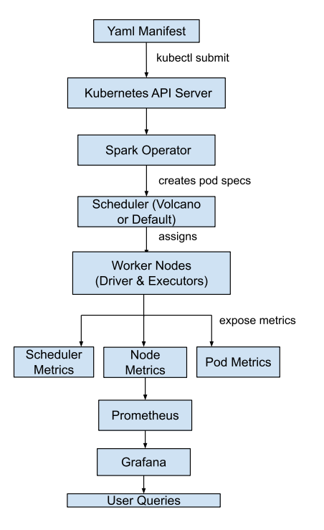

- Scheduler: Represents the scheduler being tested (e.g., default-scheduler, volcano).
- Job: Represents a single Spark job submission. It is associated with the scheduler used to run it.
- Pod: Represents an individual Kubernetes pod (either a driver or an executor) that is part of a job.
- Metric: Represents a single data point collected, such as job_completion_time_seconds or pod_cpu_utilization. Each metric is linked to the job and/or pod it describes.

6.2 Default scheduler workflow
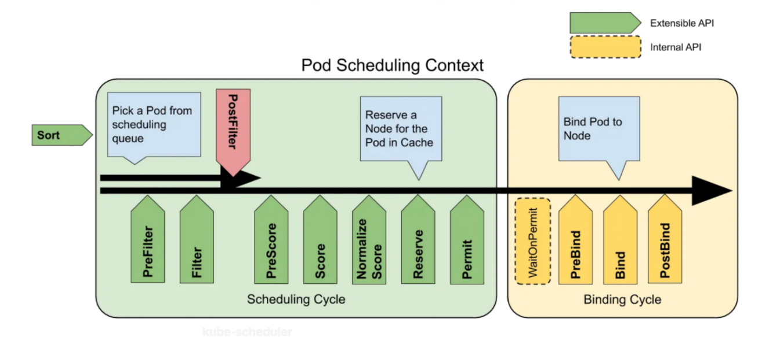

Source: Medium

6.3 Scheduling process diagram for default scheduler
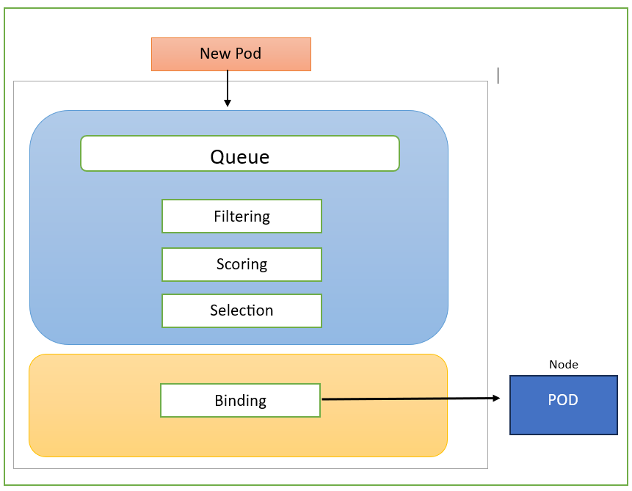

6.4 Volcano Scheduler workflow

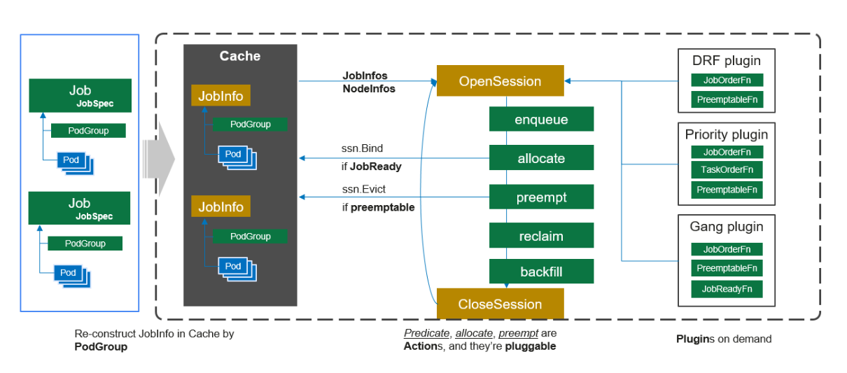
Source: volcano.sh

7. Results and Analysis
This section presents the performance metrics of the default Kubernetes scheduler as observed during the experimental phase of this project. The results are then compared with findings from existing academic and industry literature to provide a broader context for the analysis.
Experimental Performance of the Default Scheduler
The following table summarizes the key performance indicators captured using the Prometheus and Grafana monitoring stack during the execution of benchmark Spark jobs. These values represent the baseline performance against which the Volcano scheduler.

Tab 7.1: Observed Metrics for the Default Kubernetes Scheduler and Volcano Scheduler
Metric | Default Kubernetes Scheduler | Volcano Scheduler | Analysis (The "Why")
Job Success Rate | Partial (some jobs failed due to deadlock) | 100% | Default scheduler showed instability for concurrent spark jobs. Volcano handled job dependencies better.
Job Completion Time | Higher / Inconsistent (Jobs fail due to deadlocks, In case of successful job completion, e.g., 9 min 33 sec) | Lower (e.g., 2 min 29 sec) | Volcano handled job queuing and resource sharing efficiently which resulted faster pod allocation.
Scheduler Throughput | ~0.01 pods/s | ~0.98 pods/s | Volcano delivers ~100x higher throughput, meaning it can dispatch jobs and tasks far more efficiently and handle a higher volume of work.
Scheduler CPU Usage | ~0.02 cores | ~0.038 cores | Slightly higher CPU usage in volcano due to additional logic
Scheduler Memory Usage | spikes upto 43MiB | Spikes upto 47.2 MiB | Volcano used more memory to maintain job queues and task groups.
Scheduler Latency (p99) | ~158.4 ms | Spikes up to 112 ms | Volcano reduced scheduling latency through optimized queue management.
Core Scheduling Logic | Application-Unaware | Application-Aware | The default scheduler sees individual pods. Volcano sees the entire "job" as one unit, which is the correct model for Spark and other batch workloads.

8. Conclusion and Future Work

Conclusion

The comparative study between the Default Kubernetes Scheduler and the Volcano Scheduler clearly highlights the importance of using an application-aware, batch-optimized scheduling mechanism for big data workloads such as Apache Spark.

Under identical experimental conditions, the Default Kubernetes Scheduler demonstrated several limitations. It operated efficiently for lightweight or stateless workloads but struggled significantly with dependent and concurrent Spark jobs. The absence of gang scheduling led to partial job failures, resource deadlocks, and inconsistent job completion times. Although its CPU and memory consumption were slightly lower, this efficiency came at the cost of poor cluster utilization and reduced overall throughput. Hence, while suitable for general-purpose container scheduling, the default scheduler is not ideal for data-intensive batch processing.

In contrast, the Volcano Scheduler delivered consistently superior performance across all metrics. It achieved a 100% job success rate, significantly reduced job completion time (up to 3-4× faster), and exhibited higher scheduler throughput. The scheduler’s gang scheduling, queue-based resource management, and job-level fairness mechanisms enabled efficient resource sharing and prevented deadlocks. Although it consumed marginally higher CPU and memory due to advanced scheduling logic, this overhead was negligible compared to the resulting gains in performance and stability.

Overall, the findings confirm that Volcano is a more effective choice for big data and high-performance workloads on Kubernetes, offering enhanced reliability, fairness, and efficiency. It transforms Kubernetes from a general-purpose orchestrator into a capable platform for scalable, production-grade data processing.

In summary, the data indicates that for this type of parallel workload, adopting an application-aware scheduler like Volcano is not an optimization but a foundational requirement for a stable and efficient system.

Future Work

While this study provides a definitive comparison, it also opens several avenues for future research to build upon these findings:

- Expanded Scheduler Comparison: This research focused on Volcano. A logical next step would be to expand the comparison to include other prominent batch schedulers, such as Apache YuniKorn and Kueue, to analyze their respective performance, resource efficiency, and fairness policies under the same workload.

- Diverse Workload Analysis: The experiment was centered on Apache Spark. Future work should involve testing other types of batch workloads, particularly distributed Machine Learning (ML) training jobs (e.g., TensorFlow, PyTorch), which also require gang scheduling and often compete for specialized resources like GPUs.

- Large-Scale Performance Testing: The current study was conducted in a controlled, limited-node environment. A valuable follow-up would be to reproduce this experiment at a much larger scale (e.g., 100+ nodes and 1000s of concurrent pods) to identify potential new bottlenecks and evaluate scheduler performance under enterprise-level stress.

- Cost-Benefit Analysis: A detailed FinOps analysis could be conducted to translate the performance improvements (e.g., higher resource utilization, faster job completion) into tangible financial savings in an on-premises or cloud environment.

. List of References
- Kubernetes Authors. (2025). Kubernetes Documentation. Kubernetes.io. Retrieved from https://kubernetes.io/docs/home/

- The Apache Software Foundation. (2025). Apache Spark - Unified Analytics Engine for Big Data. Spark.apache.org. Retrieved from https://spark.apache.org/

- Volcano Authors. (2025). Volcano: A Kubernetes Native Batch System. Volcano.sh. Retrieved from https://volcano.sh/en/docs/

- Bernstein, D. (2014). Containers and Cloud: From LXC to Docker to Kubernetes. IEEE Cloud Computing, 1(3), 81-84.

- Zaharia, M., et al. (2010). Spark: Cluster Computing with Working Sets. In Proceedings of the 2nd USENIX conference on Hot topics in cloud computing (HotCloud'10).

- Prometheus Authors. (2025). Prometheus: From metrics to insight. Prometheus.io. Retrieved from https://prometheus.io/

- Mastering Cloud Computing: Foundations and Applications Programming: by Christian Vecchiola, Rajkumar Buyya, and S.Thamarai Selvi

- Cloud Computing Security Strategies and Best Practices: By Neha Agrawal, Rohit Kumar, Shashikala Tapaswi

- Chen, R., Ganesan, A., & Wang, C. (2020). A Performance Study of Apache Spark on a Kubernetes Cluster. Proceedings of the IEEE International Conference on Big Data (Big Data).

- H. Li, Z. Wang, L. Huang, L. Han and K. Wang. (2022). Research and Implementation of Scheduling Strategy in Kubernetes for Computer Science Laboratory in Universities. MDPI.

- Kaur, H., & Singh, J. (2021). A Survey of Job Scheduling Algorithms in Big Data Processing Frameworks. Journal of Big Data.

- Nanda, A., & T-Systems. (2021). Migrating Apache Spark Workloads to Kubernetes: A Case Study.

- Rodriguez, M. A., & Buyya, R. (2017). A Taxonomy and Survey of Scheduling Algorithms for Big Data Processing in Cloud Computing.

- The Apache YuniKorn Community. (2021). Apache YuniKorn: A Universal Resource Scheduler. Apache Software Foundation.

- The Volcano Community. (2019). Volcano: A Kubernetes-Native Batch System. CNCF.

- Wan, C. (2021). Volcano: A Kubernetes-Native Batch Scheduler for High-Performance Workloads.

- Wang, C., Li, Q., & Li, Z. (2018). A Comparative Study of Resource Management Systems for Big Data Analytics: YARN vs. Mesos. Proceedings of the International Conference on Cloud Computing and Big Data Analytics.

- Zhang, Q., Zhani, M. F., & Boutaba, R. (2017). Dynamic Resource Provisioning for Cloud-based Big Data Analytics. In Big Data Analytics. Springer, Cham.

